**612/1**

**Art and Design**

**Paper 1**

**1:40mins**

**RESOURCEFUL MOCK EXAMINATIONS 2024**

**UGANDA CERTIFICATE OF EDUCATION**

**612/1: ART AND DESIGN**

**Paper 1**

**1Hour 40minutes**

**Instructions to candidates**

*This paper consists of* **two** *sections; A and B. it has* ***four*** *examination items.*

*Answer* ***one*** *item from each section.*

*Answer* ***two*** *examination items in all.*

*Any additional item answered will* ***not*** *be scored.*

***All*** *answers* ***must*** *be written in the answer booklet(s) provided.*

**SECTION A: Art History**

**Either**

**Item 1**

The Renaissance was a cultural and Artistic movement that produced famous Art works in history. Most of the Artworks focus on subject matter (theme), style and materials. The support pictures in figures A and B below show some of the Art works.

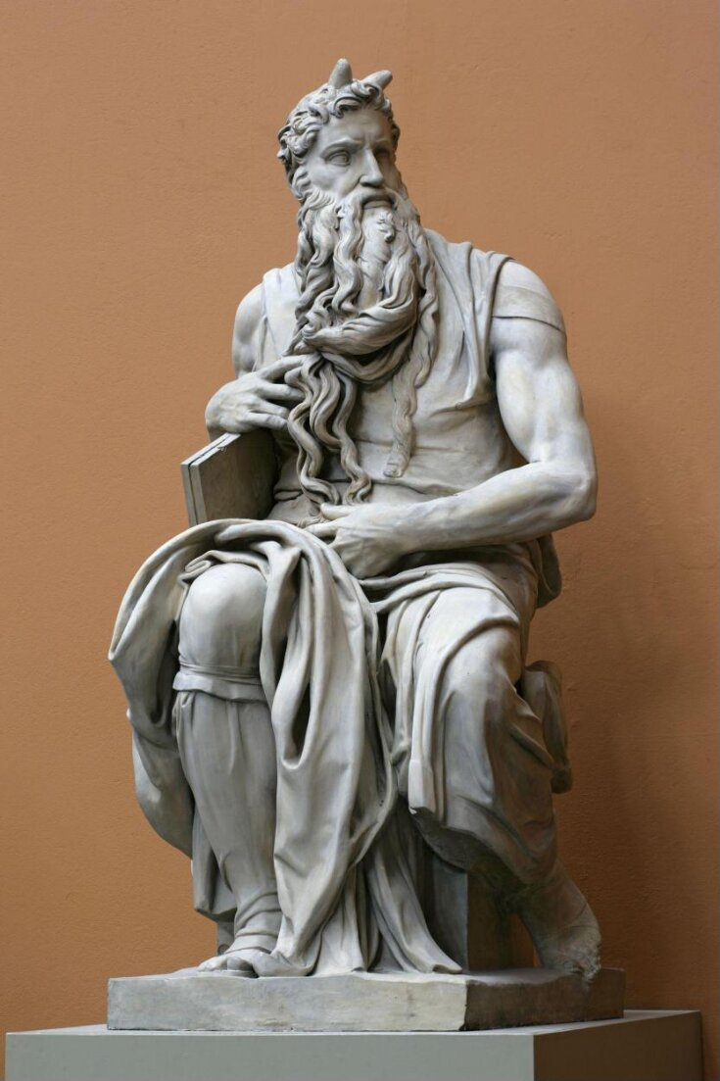 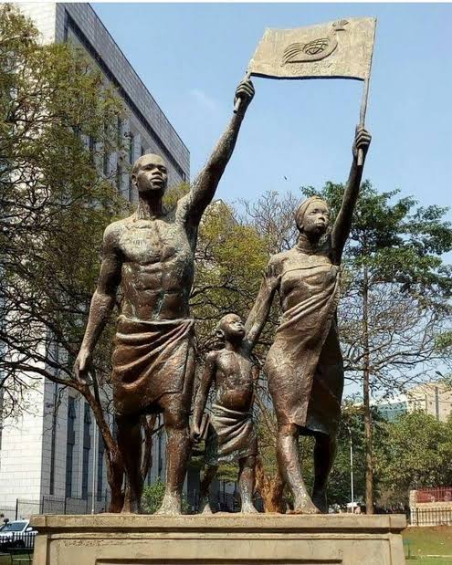

**Figure A Figure B**

Similarly, Ugandan Artists produce Art works in various forms but they still desire to borrow some of these aspects (**subject matter**, **styles** and **materials** of the renaissance of the Renaissance Artists).

**TASK:**

Analyze these aspects that can be of importance to the Ugandan artists.

**Or**

**Item 2**

Ancient Egyptian art is known for being rigid and gigantic (very big in size). Artists produced mega sizes of sculptures, pyramids and other architectural forms.

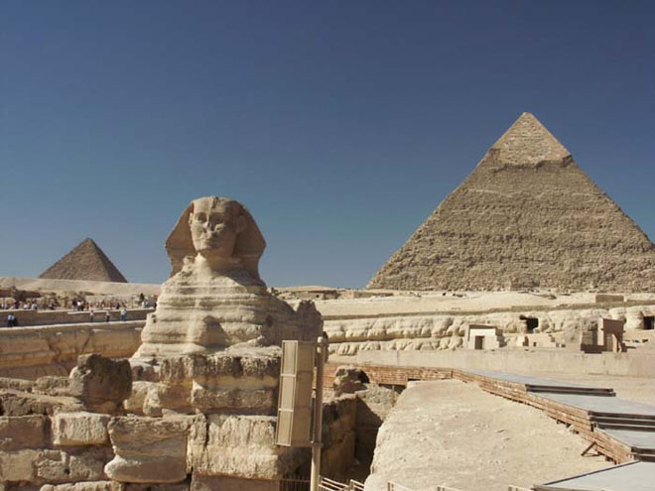

**Figure C**

Interestingly, many Uganda artists have borrowed several ideas from the ancient Egyptian art in terms of **materials, subject matter**, and **techniques**. Other artists find it difficult to make their artworks, appreciated due to their failure to utilize their environments.

**TASK:**

Provide a write-up about the possible materials subject matter, and techniques these artists can apply in that productions of their artwork, in reference to the above scenario

**SECTION B: Studio Technology**

**Either**

**Item 3:**

A community hall has been set up at the sub-county. The hall is meant to serve various purposes such as meetings and wedding ceremonies. A committee has been set up to buy curtains for the hall with a focus on the use of locally available motifs for the curtains.

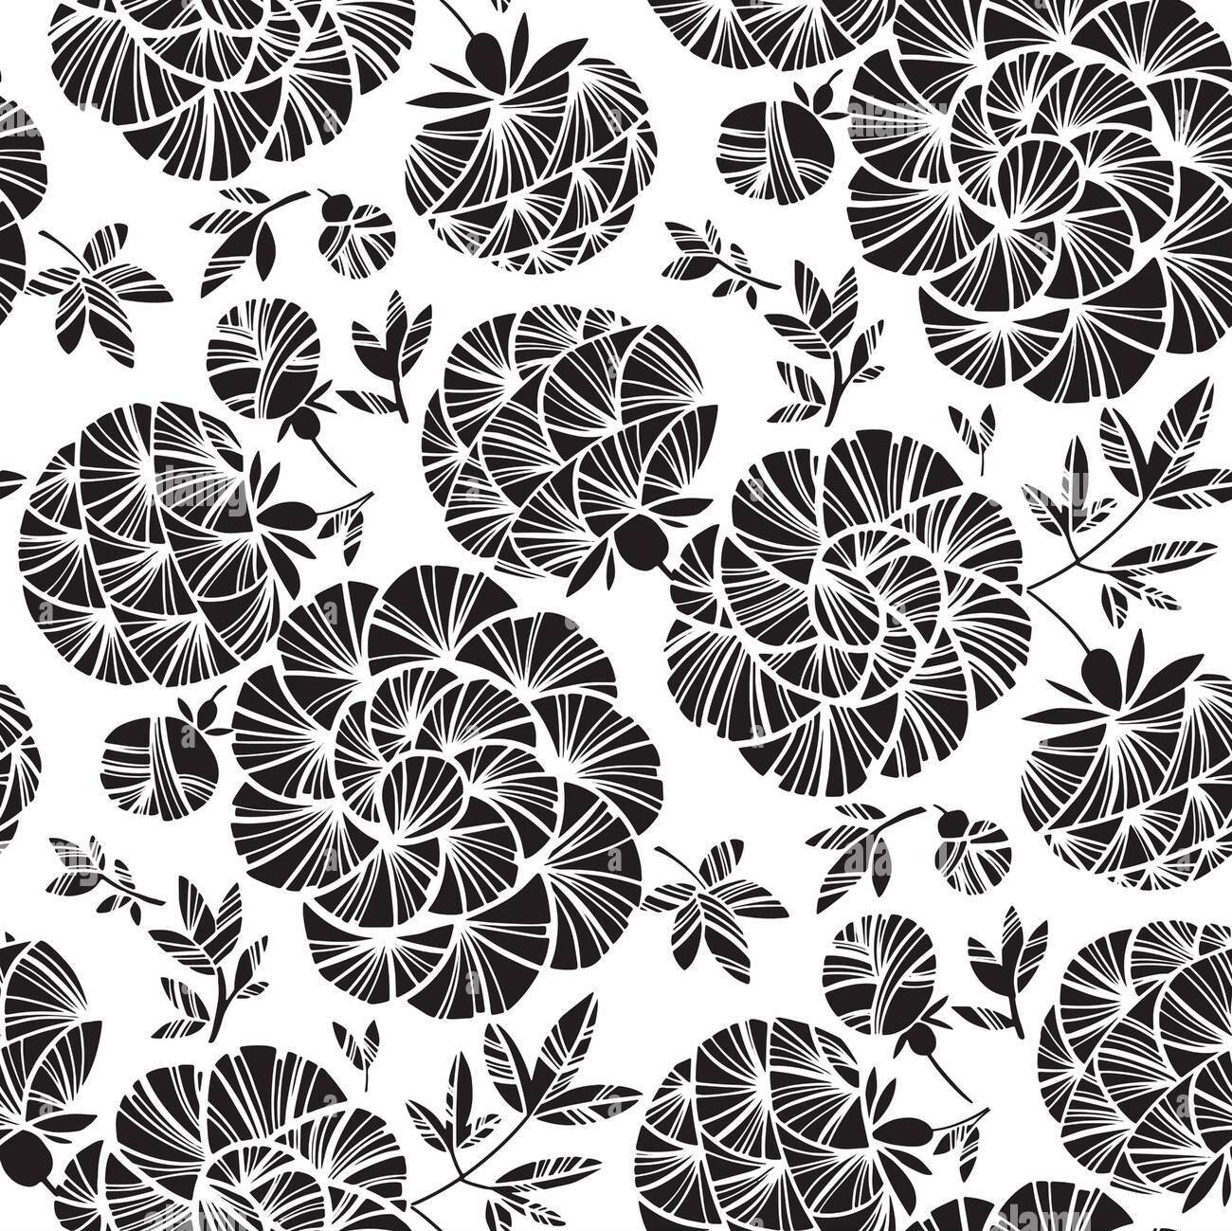

**Figure D**

You have been identified as one of the potential designers to come up with a sample of a repeated pattern on a fabric to be presented to the committee for consideration.

**TASK:**

As a designer, explain the process you would go through.

**Or**

**Item 4**

Your school plans to hold a sports day at the end of year, 2024. Several sports activities have been identified to be competed for by the different houses. Each house is required to come up with either an identification symbol, or a poster to attract new students. However, most of your house members lack the necessary artistic skills to create these graphic designs.



**Figure E Figure F**

**TASK:**

As an artist, prepare a write-up explaining to your house members the design process involved in creating any **one** of the above crafts (either E or F).

***END***